Numerical Visualizations
- Histogram
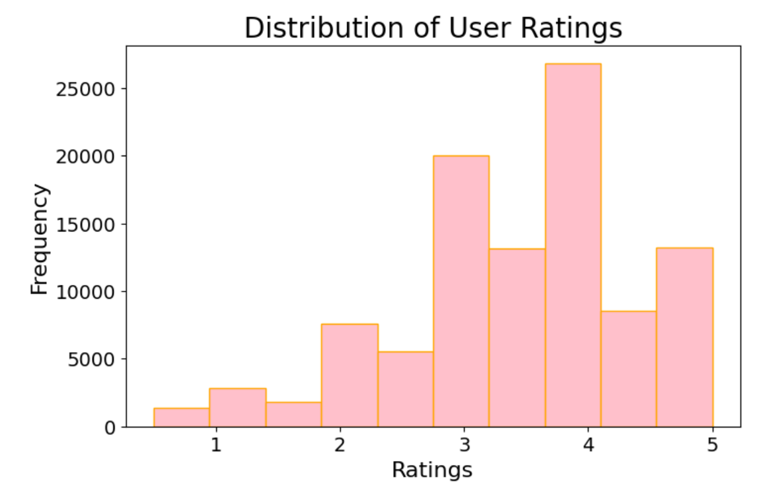
The histogram titled "Distribution of User Ratings" shows that users predominantly give high ratings, with 4 being the most frequent, followed by 3. Ratings of 1 and 2 are much less common, indicating a general tendency toward positive feedback. This skewed distribution is typical in recommendation datasets and suggests that users are more likely to rate content they enjoyed. For recommendation systems, this pattern is useful: high ratings can be prioritized to identify user preferences, while low ratings may be filtered or normalized to reduce bias and improve recommendation quality.

- Scatterplot
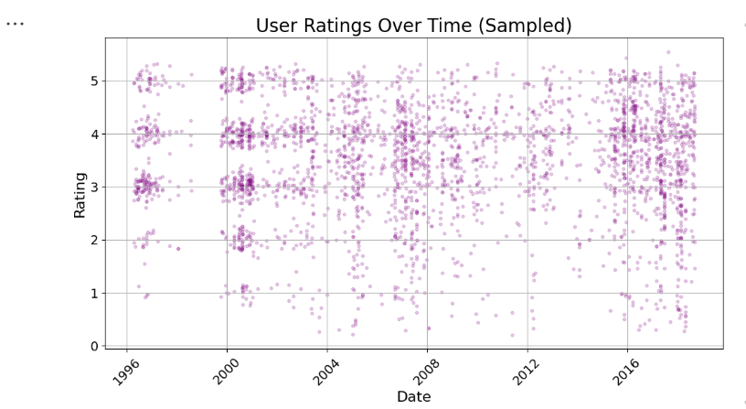
The scatterplot titled "User Ratings Over Time (Sampled)" shows how user ratings from 1 to 5 were distributed across a 20-year period, from 1996 to 2016. Each purple dot represents a sampled rating event, and the dense clustering around ratings 4 and 5 indicates that users generally gave positive feedback. Ratings of 1 and 2 are much less frequent, suggesting low dissatisfaction levels. This pattern is typical in recommendation datasets and highlights a user bias toward higher ratings. The consistent spread of ratings over time also suggests stable user engagement, which is useful for designing time-aware recommendation systems that prioritize recent and highly rated content.

- Heatmap
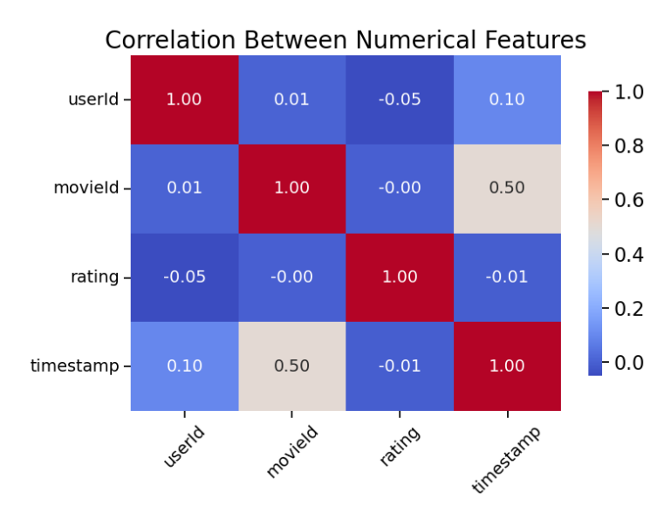
The heatmap titled "Correlation Between Numerical Features" shows that most numerical features in the dataset—userId, movieId, rating, and timestamp—have very weak correlations with each other, except for movieId and timestamp, which show a moderate positive correlation of 0.50. This suggests that certain movies were rated more frequently during specific time periods, possibly due to release trends or popularity spikes. Other relationships, such as between rating and userId or rating and timestamp, are nearly zero, indicating no meaningful linear connection between how users’ rate and when or what they rate.

Categorical Visualizations
- Horizontal Bar Plot
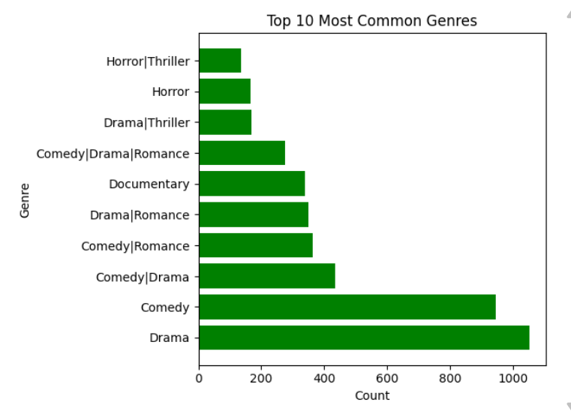
The horizontal bar chart titled "Top 10 Most Common Genres" reveals that Drama and Comedy are the most prevalent genres in the dataset, followed by combinations like Comedy|Drama and Drama|Romance, indicating frequent genre blending. Documentary also ranks high, while Thriller and Horror appear more often in hybrid forms such as Drama|Thriller and Horror|Thriller. This distribution suggests that users engage heavily with emotionally driven and multi-genre films, reflecting diverse storytelling preferences and the popularity of genre fusion in movie production.

- Grouped Count Plot
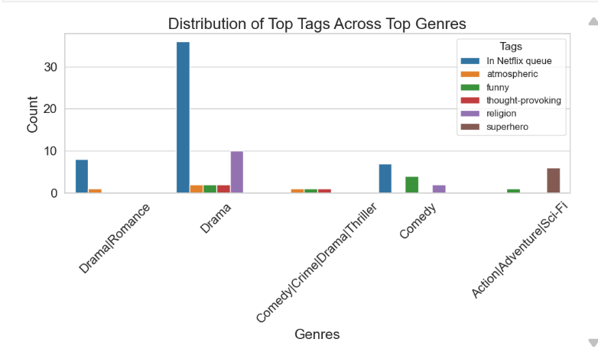
The chart shows how the most popular descriptive tags are distributed across the top five movie genres, revealing viewer associations and thematic trends. For example, the "Drama" genre is strongly linked to the "In Netflix queue" tag, suggesting high user interest or watchlist activity, while "Comedy" is most associated with "funny" and "Comedy/Crime/Drama/Thriller" shows a notable connection to "religion." Each genre displays multiple-colored bars representing tag counts, helping visualize which themes or moods are most tied to specific genres.

